* write a shell script (menu driven) ,to copy file content to another file, to display content of file on monitor, to delete a file , t rename a file.
* Execute command to see the list of files and directory in a path.

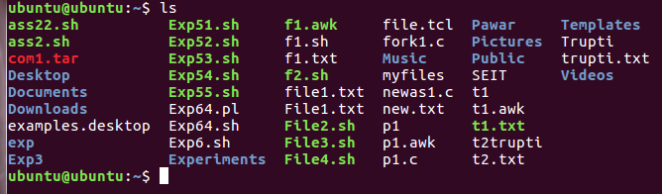

* Write a shell script to check if the given no is odd or even.

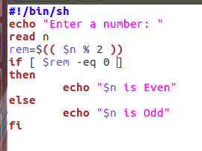 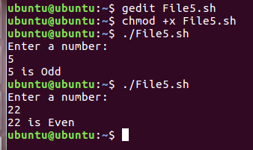

* Write a grep command to search your name in listed files using ls command(use Pipe).
* Write sed command to delete line containing EXAMINATION.

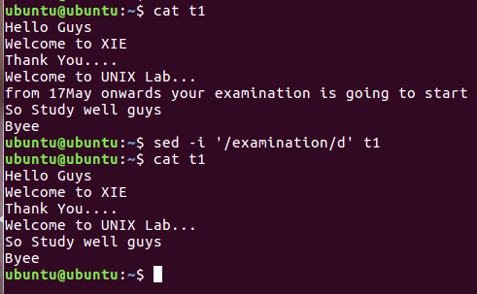

* Write a program using sed command to print Numeric data from file.
* Use sort, head, tail command with appropriate file.

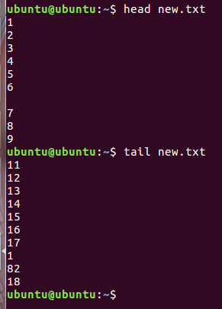

* Write a shell script: To check whether given number is prime or not

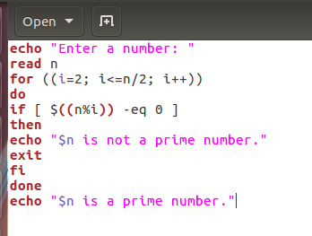

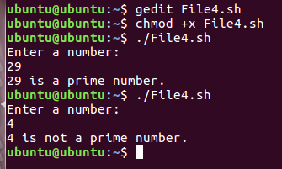

* A execute command to find the number of words character, words and lines in a file

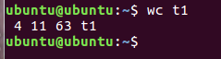

* Write sed command to replace UNIX with Linux .

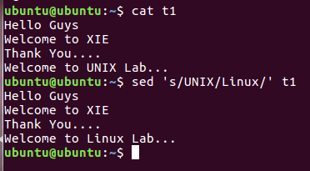

* Execute following commands. Cd,cp,ps,mv,rm,mkdir,rmdir,man,who
* Execute following networking commands, ifconfig, ping, traceroute

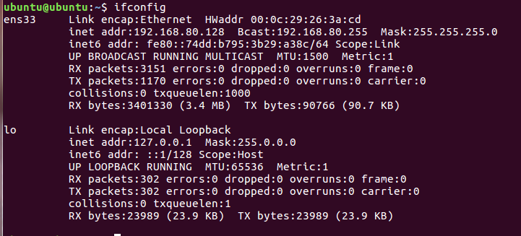

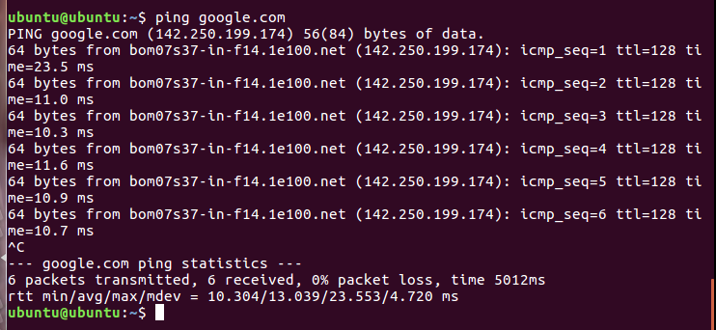

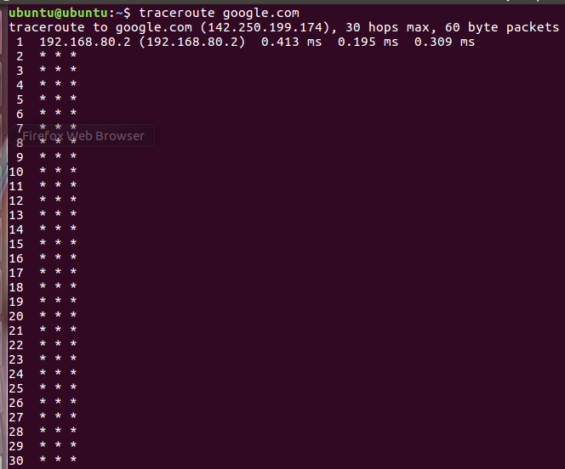

* Write sed command to delete line containing mobile number.
* command to change read write execute permission for the others( remove permission).

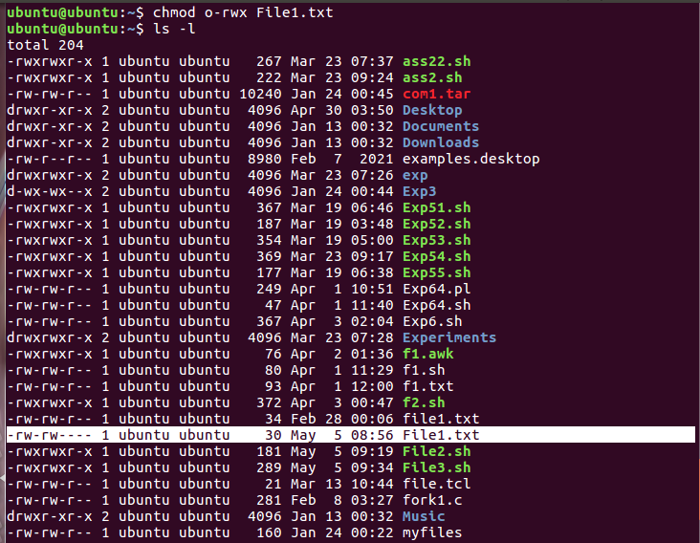

* Write sed command to delete line containing mobile number

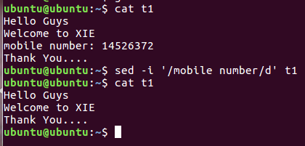

* Shell script program to count number of files in a Directory

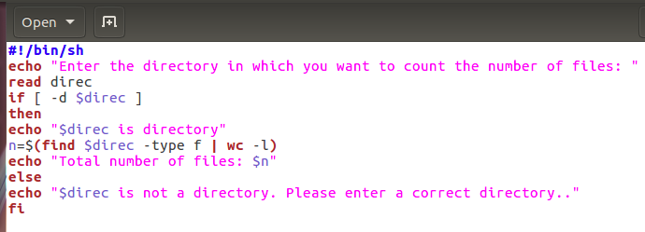

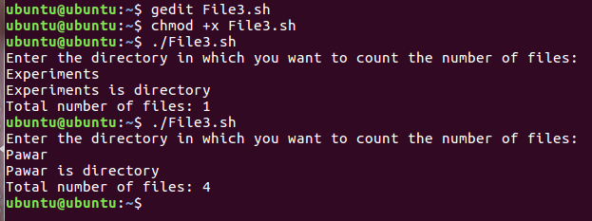

* Shell script program to rename given file.

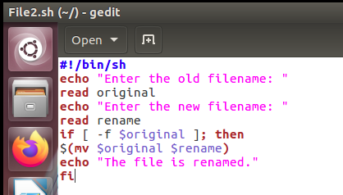

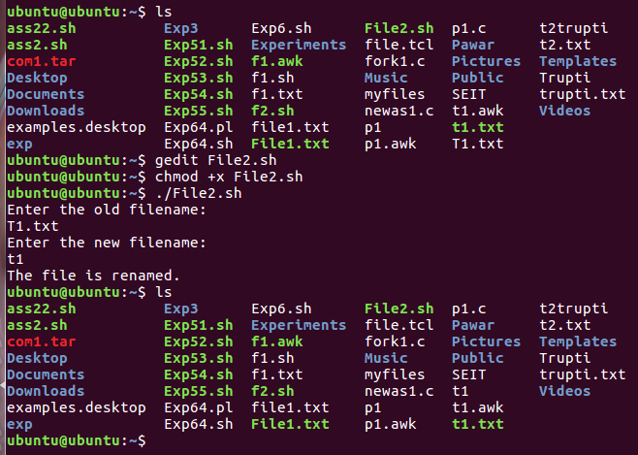

* Write a command to change read write execute permission for the others( grant permission).

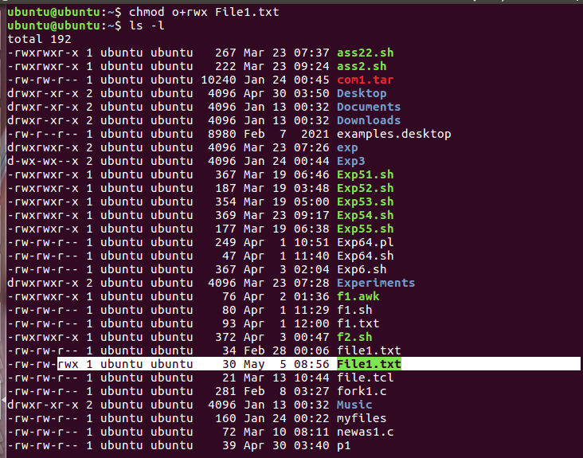

* Write sed command to delete line containing word SEIT.

